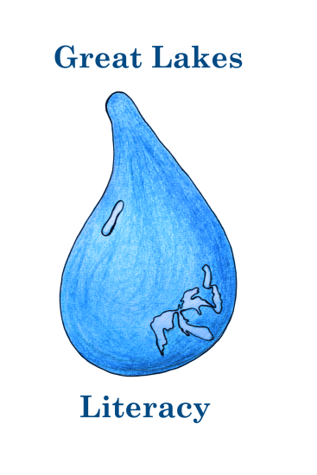
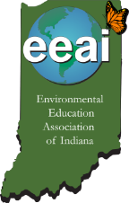
EEAI Annual Conference
September 25-27, 2015
Dunes Learning Center, 700 Howe Rd.
Chesterton, IN. 46304

Great Lakes Literacy
Call for Presenters
EEAI is currently soliciting session proposals for its Annual Conference in September. Sessions should follow the conference theme, “Great Lakes Literacy” and fit into one of the three strands: Ecology (Understand), Stewardship (Foster) or Environmental Justice (Share). Sessions will be 50 minutes long.

Understand (Ecology): These sessions will help attendees understand the essential principles and fundamental concepts about the natural habitat and ecology of Lake Michigan and the surrounding Indiana Dunes as a unique Indiana ecosystem.
Foster (Stewardship/Restoration): These sessions will help attendees understand how to develop and deliver watershed based environmental stewardship volunteer programs or service learning programs with an emphasis on water resources. While a focus on Lake Michigan and the Indiana Dunes is preferred, please also include a description of how the session and/or related resources can be applied state-wide.
Share (Environmental Justice): These sessions will help attendees communicate knowledge about how environmental issues affect water resources, the surrounding watershed and the people in that watershed. A focus on highlighting best practices case studies for building collaborative partnerships with diverse stakeholder groups to identify local environmental issues and deliver education and outreach programs that lead to solutions is preferred.

Contact Information
Name(s): Affiliation:
Address:

E-mail: Phone:

Session Title:
Track (check one): ____ Ecology ____ Stewardship/Restoration ____Environmental Justice
Prioritize date preference: ____ Saturday, 26th ____ Sunday, 27th
All session rooms will be equipped with a laptop and projector.
Brief Description (400 word limit):

Please return to: Natalie Haley, 8401 Union Chapel Road, Fort Wayne, IN. 46845 or nhaley@allencountyparks.org. For additional information: 260-449-3778 or 260-449-3180
Proposal Deadline: July 17, 2015

